**Exercise 2: E-commerce Platform Search Function**

**Product.java**

public class Product {  
 private String productId;  
 private String productName;  
 private String category;  
  
 public Product(String id, String name, String category) {  
 this.productId = id;  
 this.productName = name;  
 this.category = category;  
 }  
  
 public String getProductName() {  
 return productName;  
 }

public String toString() {  
 return "ID: " + productId + ", Name: " + productName + ", Category: " + category;  
 }  
}

**SearchDemo.java**

import java.util.Arrays;  
import java.util.Comparator;  
  
public class SearchDemo {  
  
 public static Product linearSearch(Product[] products, String targetName) {  
 for (Product p : products) {  
 if (p.getProductName().equalsIgnoreCase(targetName)) {  
 return p;  
 }  
 }  
 return null;  
 }  
  
 public static Product binarySearch(Product[] products, String targetName) {  
 int left = 0, right = products.length - 1;  
  
 while (left <= right) {  
 int mid = (left + right) / 2;  
 int comparison = products[mid].getProductName().compareToIgnoreCase(targetName);  
  
 if (comparison == 0) return products[mid];  
 else if (comparison < 0) left = mid + 1;  
 else right = mid - 1;  
 }  
 return null;  
 }  
  
 public static void main(String[] args) {  
 Product[] products = {  
 new Product("P001", "Laptop", "Electronics"),  
 new Product("P002", "Shirt", "Apparel"),  
 new Product("P003", "Phone", "Electronics"),  
 new Product("P004", "Shoes", "Footwear"),  
 new Product("P005", "Book", "Education")  
 };  
  
 Product foundLinear = *linearSearch*(products, "Phone");  
 System.*out*.println("Linear Search Result: " + (foundLinear != null ? foundLinear : "Not Found"));  
  
 Arrays.*sort*(products, Comparator.*comparing*(Product::getProductName));  
 Product foundBinary = *binarySearch*(products, "Phone");  
 System.*out*.println("Binary Search Result: " + (foundBinary != null ? foundBinary : "Not Found"));  
 }  
}

**Output:**

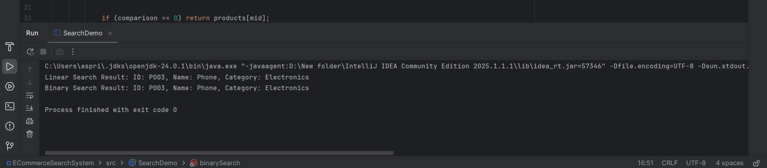

**Exercise 7: Financial Forecasting**

**FinancialForecast.java**

import java.util.Scanner;  
  
public class FinancialForecast {  
  
 public static double forecast(double initialAmount, double rate, int years) {  
 if (years == 0) {  
 return initialAmount;  
 }  
 return *forecast*(initialAmount, rate, years - 1) * (1 + rate);  
 }  
  
 public static void main(String[] args) {  
 Scanner sc = new Scanner(System.*in*);  
  
 System.*out*.print("Enter initial amount (₹): ");  
 double amount = sc.nextDouble();  
  
 System.*out*.print("Enter annual growth rate (%): ");  
 double rate = sc.nextDouble();  
 double growthRate = rate / 100;  
  
 System.*out*.print("Enter number of years: ");  
 int years = sc.nextInt();  
  
 double futureValue = *forecast*(amount, growthRate, years);  
  
 System.*out*.printf("Future Value after %d years: ₹%.2f\n", years, futureValue);  
  
 sc.close();  
 }  
}

**Output:**

